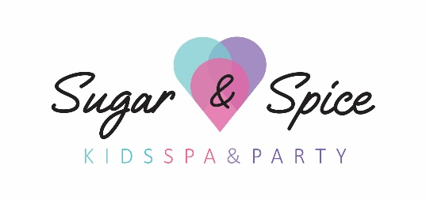
VISITOR PANDEMIC QUESTIONAIRE
Date of Visit: _____________________ Time of Arrival: _________ Time of Departure: ___________
Spa Guest Name(s): __________________________ Parent/Guardian Name: ____________________

Type of Service: __________________________________________________________

It is our goal at Sugar & Spice Kids Spa & Kids Party to maintain an environment free of risks for all persons entering our facilities including our staff.

Instructions:
During this time of pandemic awareness, we are asking that all visitors fill out the questionnaire below before making any kind of physical contact (eg: shaking hands) or entrance further from reception.
If you answered "yes" to any of the questions, verbally inform the Spa Technician. Please immediately hand your completed questionnaire to the Spa Technician. Our Spa Technician will review the questionnaire with you and if we feel the spa is at risk we will request that you reschedule your appointment.

Please Note: If you are currently experiencing flu symptoms or have recently travelled outside of Canada, we will ask that you reschedule your appointment.

Thank you in advance for your cooperation and helping to keep everyone safe from the spread of pandemic related diseases.

1) | Has anyone in your party traveled outside of Canada in the last 14 days? | YES □ NO□
2) | Has anyone in your party tested positive for COVID-19 or had close contact with a confirmed case of COVID-19 without wearing appropriate PPE? (This includes family, friends, acquaintances or any other person that you are aware of) | YES □ NO□
3) | Does anyone have any of the following symptoms? • Fever • New onset of cough • Worsening chronic cough • Shortness of breath • Difficulty breathing • Sore throat • Difficulty swallowing • Decrease of loss of sense of taste or smell • Chills • Headaches • Unexplained fatigue/malaise/muscle aches (myalgias) • Nausea/vomiting, diarrhea, abdominal pain • Pink eye (conjunctivitis) • Runny nose or nasal congestion without other known cause now or within the last 14 days? | YES □ NO□

Signature: ________________________ Witness: _________________________

Revised: June 23 2020

